**IT24101356**

**M.S.D Vidanagamage**

**PS_Lab06**

1. A screenshot of a computer

   Description automatically generatedi)

ii)

1. I)

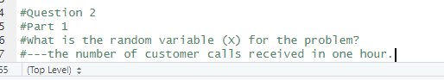

ii)

iii)

